When our pupils started the new school year in September, most were returning to the classroom for the first time in almost six months. Research conducted by the EEF (amongst others) strongly suggests that compensating for the negative impact of school closures on the gap will require a sustained response. The government announced in June that it was making available £1 billion of funding to support children and young people to catch up. This includes a one-off universal £650 million catch-up premium for the 2020 to 2021 academic year to ensure that schools have the support they need to help all pupils make up for lost teaching time.
“Every school will have been affected by Covid-19 differently and school leaders are best placed to understand the needs of their school communities. The right way to support pupils will differ between schools and must be informed by the professional judgement of teachers and school leaders”.
The amount allocated to Special Schools is £240 for each place for the 2020 to 2021 academic year. For Cicely Haughton School, that =
£12, 000 (50 pupils x £240). Additional weighting has been applied to specialist settings, recognising the significantly higher per pupil costs they face.
This document shows how Cicely Haughton School plan to support our pupils to return effectively to school:
- Our focus is on supporting the Mental Health and Wellbeing of our students to enable them to access the opportunities that we have created in school. For some children they will need an enhanced offer of support with additional time spent on mental health, wellbeing and social skills development.
- Additionally, we will purchase
This will be at the core of all catch up work as many children will have not been in formal school setting for a number of months.
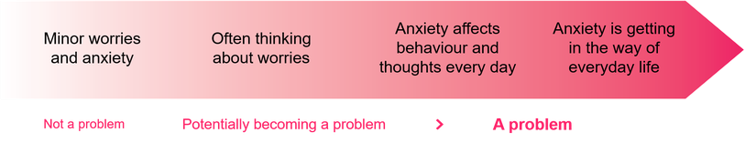

 | What | Why | Who | How | Cost | Impact
Teaching Strategies | Enhanced IT capacity | Increased access to improved IT resources (Laptopsx10) enabling more pupils to use and availability to support home/remote learning as and when required. There will be two further laptops provided by the government additionally to complement this. | Available for all pupil as and when required | Curriculum planning will identify increased opportunity to use these technologies and provide opportunities for pupils to use remote learning tools to support usage at home. Staff will identify pupils who have not been engaging with remote learning, who did not have access to technology needed to carry out remote learning, or who have experienced difficult family circumstances that have impacted upon their access to remote learning | Laptops £467  (X10)  £4670 | Pupils are able to access remote learning activities effectively. Outcomes improve, in particular for vulnerable pupils and any gap in attainment with their peers is reduced
Targeted Support | Intervention programmes  One to one and small group tuition  Nurture | The Covid-19 lockdown led to a potential increase in anxiety, isolation and trauma for pupils. In 2020/21, the school needs to so what it can to restore the balance for our children and provide a safe, happy atmosphere where everyone can thrive and learn  Pupils may be experiencing a variety of emotions in response to the coronavirus outbreak, such as anxiety, stress or low mood. This may particularly be the case for vulnerable children, including those with a social worker. | Additional Teaching Assistant 1.0 (2 terms) | School staff will work with pupils who struggle to reengage in school, who are at risk of being persistently disruptive, including providing support for overcoming barriers to attendance and behaviour and to help them reintegrate back into school life.  Additional time/support to readjust to school; some pupils may be showing signs of anxiety or depression. | Grade 6 TA  (2 terms)  £19,500
 |  |  |  |  |  | Children who are suffering from particular anxieties or trauma are helped to improve their mental well -being and they feel safe

Total projected spend to date: £24,170
- Staff time £19,500
- IT Resources £4,670

