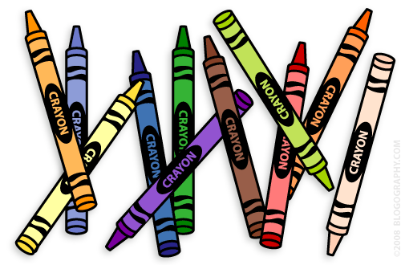F:\2017 2018\Class\image001.jpg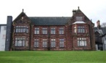

**PSHE Topics:**

Our PSHE theme this term in ‘Living in the Wider World’. The topics are called ‘One World’ and ‘Aiming High’.

‘One World’ is based on a case study of a fictional girl called Chiwa, who lives in Malawi. The children will explore different aspects of her life in each lesson. It is inspired by the idea that people’s life experiences and opportunities differ throughout the world and that our actions can have both positive and harmful effects on people living in different countries. It aims to enable the children to explore the concepts of inequality and stereotypes and encourages children also learn about climate change and its effects, fair trading practices and organisations that help people like Chiwa. They will also learn about how to be a good global citizen.

*Dear Parents and Carers,*

*Happy new year and welcome to our class newsletter. I have provided some information which you may find useful for the Spring Term. Mr Kirkby continues to be our full time teaching assistant this term. We also welcome Mrs Herritts, who will be working in our class Monday-Wednesday. Mr Dreher will now be teaching the class on a Wednesday. We welcome our new pupils and families and look forward to working with you all this term.*

*Miss Benson*

**Notes:**

Class Dojo

I will continue to be using Class Dojo as my main means of communication, you can download the app on your phone or use it via a computer/laptop and instantly send messages to myself which I will respond to quickly during school hours.

If you would like to speak to me please feel free to call the school on 01782 550202.

It is important that your child reads every day. We have Bug Club which has a wide range of online books for your child to access at the correct level. Please feel free to use this at home as part of your bedtime routine.

**Miss Benson’s Class**



**Our Curriculum**

We will be changing the way we teach Maths this term. We will be teaching POWER MATHS in personalised learning groups. So your child will not be working in class groups for maths. This will be similar to how we teach English. Your child’s maths teacher will set maths homework every Monday.

English is being taught in English groups, this will start w/c 10.1.22. Your child’s English teacher will set homework on a Tuesday and Wednesday each week.

In science our topic this term are ‘Forces and Magnets’ and ‘Rocks’.

Our topic this term for history and geography is ‘Chocolate’.

We will also be teaching French, art, RE, computing and Nurture.

**Physical Education:**

Our PE sessions will be on a **MONDAY** and **THURSDAY**. PE kits will be provided by school. Please send in trainers for PE on these days.

