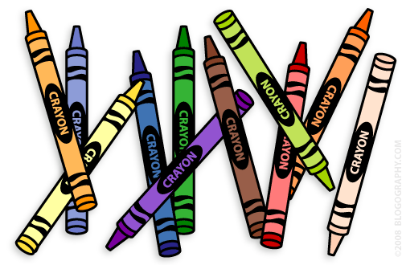F:\2017 2018\Class\image001.jpg

**Nurture Class**

**Notes:**

- Journals - Please use the journal as a means of communication. Feel free to use the journal to inform us of any relevant information and we will use the journal to update you with information throughout the week.

- Class Dojo – I will be using Class Dojo as another means of communication, you can download the app on your phone or use it via a computer/laptop and instantly send messages to myself which I will respond to quickly.

- If you would like to speak to me please feel free to call the school on 01782 550202.

**Polite Requests:**

- Please send coats in with your child when it is cold as we will still be using the outside areas.

- Please send in Wellies where possible as we will be going on walks and using the outdoor areas over the winter.

Thank you in advance

Dear Parents and Carers,

Welcome to the Nurture class. I would like to introduce myself, Mr Paul Cooper as your child’s class teacher and working alongside me are Mr Twigg, and Miss Walklett. I have provided some information which you may find useful for the first half of the Autumn Term.

Mrs Paul Cooper



**Curriculum**

During this term our topic will be All about me, with our main focus being establishing relationships with adults and children in the class and learning the class routines. The children will remain with their class group (bubble) each day. English will be differentiated within the classroom, which means the children do not have to travel to another classroom to be taught.

Maths homework will be set on a Monday evening to be returned on Tuesday. English homework will be set on a Tuesday evening to be returned on a Wednesday, if your child’s homework is reading please write your comments in the reading record and return with the book.

**Physical Education:**

- Our PE sessions will be on a Tuesday and Thursday. Please send in a T-shirt, shorts, tracksuit bottoms and trainers on a Thursday, these will then be sent home on a Friday, to be returned the following Thursday.

