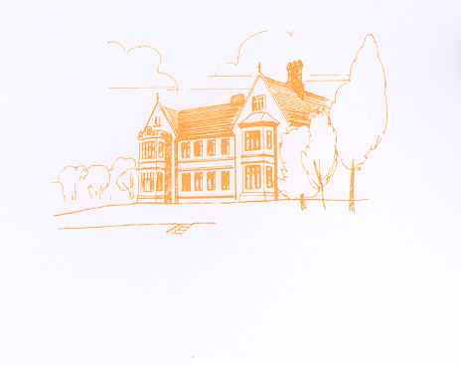
Cicely Haughton School
Pupil premium Impact 2017/18

 | Focus Area | Summary of actions | Cost/budget area | Evidence/data of impact
Literacy | To improve reading abilities for all pupils eligible for PP. | Purchasing of class readers.  Mentoring.  Staffing of one to one reading interventions and reading support.  Subscription to Wordsmith Online readers  Purchasing of Word shark licences.  Purchasing of specialist writing resources for individuals.  Purchasing of Nessy.  Purchasing of RWI phonics GP scheme. | £2,000 Learning/resources  (LR)  £2,000 Staffing  £400 LR  £400 LR  £100 LR  £300 LR  £1,500 LR  Total £6,700 | Data collated on yearly tracker/EAZ  Data comparison from benchmark  Data from YARC  CRE RWI screening half termly basis.
 | Improved writing abilities within 12 months of being at CHS.
 | Narrow any gap between PP children and national expectations.
Numeracy | To improve maths abilities for all pupils eligible for PP. | Purchasing of Number Shark licences.  Mentoring.  Staffing of One to one numeracy interventions.  Improved IT resources-purchasing of purple mash. | £300 LR  £2,000 Staffing  £150 LR  Total £2,450 | Records of interventions.  PSP yearly data analysis.  Benchmark assessment progress.  SAT’s performance where relevant  Data collated on yearly tracker/EAZ
 | Narrow any gap between PP children and national expectations.
Behaviour | Increased pupil motivation to learn and to make positive choices. | Purchasing of BLOT.  Mentoring.  Purchasing of stickers, certificates and small reward prizes for class level. | £2,000 LR  £200 LR  Total £2,200 | Head teachers star of the week board of fame.  Data and evidence to be used in MA meetings, parents’ evenings and for staff to use when implemented support at class level.  Boxall Profiles.
 | Improve monitoring of behaviour to facilitate swifter implementation of interventions where necessary.
 | Focus Area | Summary of actions | Cost | Evidence/data of impact
Social/Mental Health/wellbeing | Improve focus and concentration throughout the school day. | Free toast/snack at breakfast.  Staff to be provided relevant training to support individuals with specific needs.  Purchasing of resources to engage children on breaks.  Funding for staffing/Staff employment to deliver/resource enrichment activities.  Whole Academy CPD on relevant topic TBC. | £1,500 Catering  £2,000 Training  £1,000 LR  £6,000 Staffing  £3,500 Training  Total £14,000 | Use BLOT to analyse number of interventions required due to children being hungry.  Less negative inputs on BLOT and less use PI.  Photographic evidence of more relaxed children enjoying the outside of timetable activities.  Pupil voice/questionnaire evidence.  Less negative inputs on BLOT and less use PI.  More confident staff with better understanding of how to support the children more appropriately consequently more relaxed children able to access more opportunities and activities.  Staff forum feedback /questionnaire evidence.  Higher levels of pupil engagement.  Boxall Profiles.
 | Positive mental well-being days/activities.
 | Staff training/Inset
 | To improve the level of exercise children are accessing to supplement the PE/Sports curriculums.
 | Offer a wider range of activities on enrichment.
 | Staff CPD
Attendance | Improve monitoring and attendance of PP children. | To purchase ATTEND services on an annual basis.  Individual monitoring of PP attendance by JRO. | £1,100 EWO  Total £1,100 | Improved attendance for individual PP children.  Parental feedback when ATTEND involved.
 | Support parents of PP children in getting their child into school and for them to attend relevant meetings.
Opportunities | Offer children the opportunity learn how to play a musical instrument. | Purchasing of music instructor on a weekly basis.  Funding of horse riding lessons through RDA/Lodge Farm. | £3,420 Music Tuition  £3,000 LR  Total £6,420 | Opportunity for children to play an instrument in school and as part of the school performances-increased self-esteem, sense of worth.  Opportunity for children to bond with horses, achieve awards in association with the BHS-Increased sense of self-worth self-esteem-Boxall Profiles.
 | Offer children who perhaps could not afford to pay for lessons the opportunity to have riding lessons.
 | Desired outcome/focus | Summary of actions | Cost | Evidence/data of impact
Technology | To provide lap top/Ipad to improve engagement | Purchasing of such resources for individuals use.  Purchasing of external trainers to familiarise staff with the resources to better engage learners. | £2,000 IT  £1,500 Staffing  Total £3,500 | Improved awareness of use of resources.  Positive impact upon engagement-BLOT data.  Boxall profiles.  Engagement tools.  Annual data analysis of progress.  Increased awareness of new curriculum and expectations.
 | Additional resource training.
Others | To improve activity options for breaks to help with children who find unstructured time difficult. | Purchasing of activities for children to participate in/games to play etc for indoor club.  Buying in of trained support services eg Dove to train children in these skilled awards. | £1,150 LR  £3,000 Staffing  Total £4,150 | Improved attendance of indoor club.  Decrease in incidents on break times.  Pupil voice/questionnaires.  School council meeting minutes.  Calmer breaks for all.
 | Set up/development of school based programmes eg-social groups, circle of friends, peer mentors, playground buddies.
 |  | Total predicted Income-  Total allocated- | £40,920  £40,920

